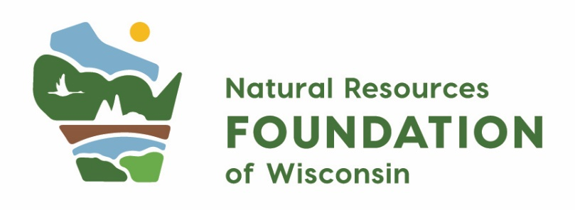

Norma & Stanley DeBoer Quiet Trails Fund
Grant Application

Overview
Project Title
Organization Name
Contact Information
Name, Title, Email, Phone
Organization Website
If applicable
Check Payable
Organization Name, c/o, Address, City, State, Zip
Project Timeframe
Project Start and End Date
Project County
County impacted by this project
Amount Requested ($)
Total Project Cost ($)
Project Description
1-2 sentence overview of your project, including what this funding will help you accomplish. This language will be shared with the public via NRF’s communications.
Grant Eligibility | ☐ Yes, I have reviewed the eligibility guidelines for this grant program and confirm that my project meets all requirements.  Please check one:  My organization is a:  ☐ Non-profit organization:  If non-profit, please provide  Employer Identification Number (EIN): _____________________  ☐ Federal, state, or local government agency  ☐ American Indian nation or tribal community  ☐ Accredited college or university
Applicant Commitment  Required | ☐ To the best of my knowledge, all information provided in this grant application is true and accurate. I understand that the Natural Resources Foundation has sole discretion in awarding grants. I understand that if I am awarded a grant, the Natural Resources Foundation shall have the right to provide others with the project description. I understand that if I am awarded a grant, I will be required to submit a grant report within 1 year of receiving the grant to be considered for future funding.

- Narrative
- The What: Tell us about your project – what do you plan to do with a grant from NRF? What are your goals, objectives, and outcomes? (suggested maximum 250 words)

- The Who: Who will be involved in and impacted by your project? (suggested maximum 250 words)

- The How: How will grant funds be used and how do you plan to measure success? Please share a general timeline of project activities and milestones. (Suggested maximum 250 words)
- The Why: What gaps, barriers, or challenges does the project address? What impact do you hope this project will have? (suggested maximum 250 words)

- Optional: Is there anything else about your project you’d like us to know? (suggested maximum 250 words)

- Budget
- In the table below, enter budget information for the project. The total for the “Norma & Stanley DeBoer Quiet Trails Fund” column may not exceed $1,000.
- List any other pending or received funding support for this project. Include the dollar amount and status of those requests.

Line Item | Norma & Stanley DeBoer Quiet Trails Fund Portion ($) | Other Funding  (List Source, $) | Total Cost ($)
 | $ | $ | $
 | $ | $ | $
 | $ | $ | $
 | $ | $ | $
 | $ | $ | $
 | $ | $ | $
 | $ | $ | $

- Requirements
Required Attachments | ☐ Yes, I have included the project budget (using either the template provided, or another document that works best for my project).
Applicant Commitment | ☐ I understand that if I am awarded a grant, the Natural Resources Foundation has the right to share the project description with the public. I understand that if I am awarded a grant, I will be asked to submit a grant report within one year.

