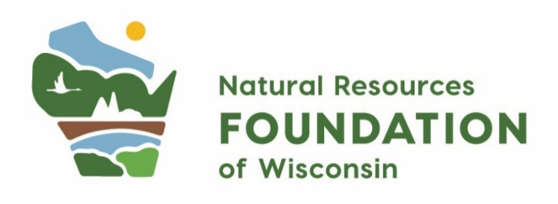
C.D. Besadny Conservation Fund
Grant Application
- Overview
Project Title
Organization Name
Contact Information
Name, Title, Email, Phone
Organization Website
If applicable
Check Payable
Organization Name, c/o, Address, City, State, Zip
Project Timeframe
Project Start and End Date
Project County
Wisconsin county impacted by your project
Project Location
If applicable provide Google Maps link and/or map attachment.
Amount Requested ($)
Total Project Cost ($)
Matching Funds ($)
1:1 match is encouraged but not required; match may include in-kind such as volunteer hours

Project Description
1-2 sentence overview of your project, including what this funding will help you accomplish. This language will be shared with the public via NRF’s communications.

Grant Eligibility | ☐ Yes, I have reviewed the eligibility guidelines for this grant program and confirm that my project meets all requirements.  Please check one:  My organization is a:  ☐ Non-profit organization:  If non-profit, please provide  Employer Identification Number (EIN): _____________________  ☐ Federal, state, or local government agency  ☐ American Indian nation or tribal community  ☐ Accredited college or university
Grant Priorities  Required: Please select at least one of NRF’s priority focus areas that your project addresses. | ☐ Our project engages communities in Wisconsin who have been historically marginalized, underrepresented, or excluded.  ☐ Our project benefits Wisconsin’s rare species and/or natural communities identified in the Wisconsin Wildlife Action Plan.  ☐ Our project builds climate resiliency of Wisconsin’s lands, waters, and wildlife through natural climate solutions or climate adaptation.

- Narrative
- The What: Tell us about your project – what do you plan to do with a grant from NRF? What are your goals, objectives, and outcomes? (suggested maximum 250 words)

- The Who: Who will be involved in and impacted by your project? How will your project engage those who have been historically marginalized, underrepresented, or excluded? (suggested maximum 250 words)

- The How: How will grant funds be used and how do you plan to measure success? Please share a general timeline of project activities and milestones. (Suggested maximum 250 words)

- The Why: What gaps, barriers, or challenges does the project address? What impact do you hope this project will have? (suggested maximum 250 words)

- Optional: Is there anything else about your project you’d like us to know? (suggested maximum 250 words)

- Optional: Include 1-2 photos representative of your project.

- Budget

- In the table below, provide budget information for the project. The total for the “C.D. Besadny Fund Portion” column should not exceed $5,000. Alternatively, you may attach a separate, pre-existing budget document.
- List any other pending or received funding sources for the project. Include the dollar amount and status of those requests.

Organizations are welcome to include up to a 20% indirect fee on their grant.

When estimating the value of volunteer time, please refer to Independent Sector's valuation: https://independentsector.org/research/value-of-volunteer-time/

Line Item | C.D. Besadny Fund Portion ($) | Other Funding (Source, $) | Total Cost ($)
 | $ | $ | $
 | $ | $ | $
 | $ | $ | $
 | $ | $ | $
 | $ | $ | $
 | $ | $ | $
Total: | $ | $ | $

- Requirements
Required Attachments | ☐ Yes, I have included the project budget (using either the template provided, or another document that works best for my project).
Applicant Commitment | ☐ I understand that if I am awarded a grant, the Natural Resources Foundation has the right to share the project description with the public. I understand that if I am awarded a grant, I will be asked to submit a grant report within one year.

